NAAN MUDHAVAN PROJECT DOCUMENT

**COURSE TITLE** : DIGITAL MARKETING

**COLLEGE CODE** 1105

**COLLEGE NAME** : GOJAN SCHOOL OF BUSINESS AND TECHNOLOGY

**PROJECT TITLE** : CREATING AN SPONSORED POST FOR INSTAGRAM

**PROJECT TEAM ID** : NM2023TMID05724

**TEAM LEADER**

**NM ID** : 036295D6FCADDF9BDC542A7D31A50A9C

**NAME** : KOUSIGA G

**TEAM MEMBER 1**

**NM ID** : 8DCD502C9FA011BABB842D8CD53E1EC9

**NAME** : DEKONDA REVATHI

**TEAM MEMBER 2**

**NM ID** : 372BB2E51C6FD32BBB042D1CEEB322BF

**NAME** : SABITHA M

**TEAM MEMBER 3**

**NM ID** : 94DA73B195E26D48AE948481DAB51567

**NAME** : SIVAPRAGASAM J

**TEAM MEMBER 4**

**NM ID** : 6B6591BA0E472F79EE44706C0F12E100

**NAME** : SURESH KUMAR C H

**BRAND NAME** : MUSICO PHILE

**BRAND MAIL-ID** : [musicophile099@gmail.com](mailto:musicophile099@gmail.com)

**PASSWORD** :Musico@099

**SOCIAL MEDIA LINK** :

https: <https://www.facebook.com/people/Musico-Phile/pfbid0aARz9TPEWzNxeuoNCULThQ75KL29UsJZzWhBtnU2qvkgzK2ChLZC3cafNmvVUvN4l/?mibextid=ZbWKwL>

**DRIVE LINK** : <https://drive.google.com/file/d/1-iqclKCwc6j0urhAllJtcVPGDKjKY4x-/view?usp=drivesdk>

# HOW TO CREATE A SPONSORED POST ON INSTAGRAM

1. **Choose your content:**

Decide what type of content you want to promote. It could be a photo, video, carousel post, or a story. Make sure it aligns with your campaign goals.



* 1. *Choose Your Advertising Goals:* instagram will ask you about your advertising goals. Select the goal that best matches what you want to achieve with your post with musical instruments
  2. *Select Your Business Type:* Specify the type of business you have, and click "Next."
  3. *Enter Account Information:* You'll need to provide information about your business, such as the business name, website, and location. Follow the on-screen instructions to complete this step.

.

* 1. *Create Your First post:* After setting up your billing, you can start creating your first post campaign. You'll need to specify the campaign type, budget, targeting options, ad format, and more.
  2. *Review and Launch:* Review your campaign settings and make sure everything is set up as you want. Then, click "Launch" to start running your ads.
  3. *Ad Creation:* After launching your campaign, you'll need to create ads within the campaign, specifying ad copy, keywords, and other details.

That's it! You've now created a Instagram sponsored post and launched your first ad campaign. Make sure to monitor your campaigns regularly and make adjustments as needed to optimize their performance.

# Selecting brand:



1. **Google Ads Account:**

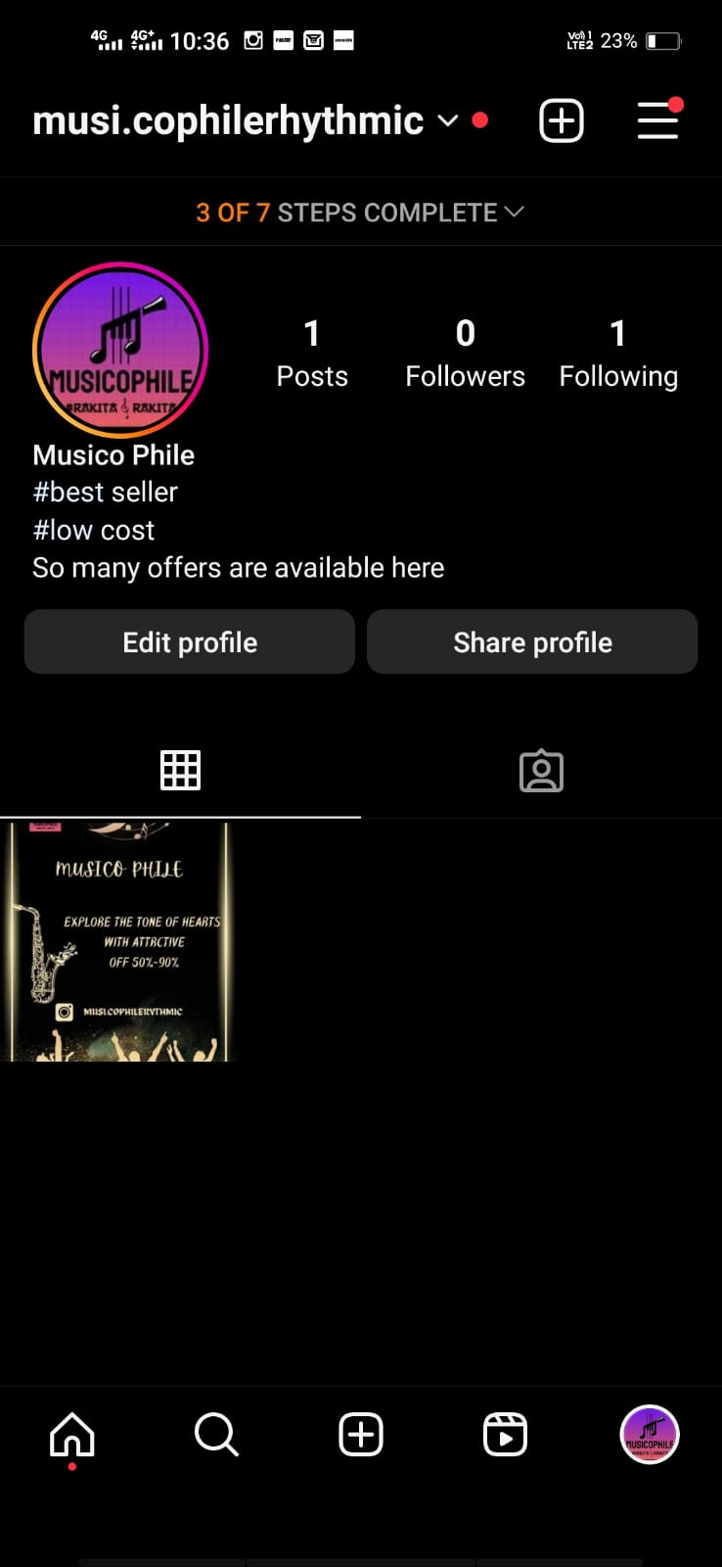

# Selecting Template :

1. **Set Your Goals:** Determine your objectives for the sponsored post. Are you looking to increase brand awareness, drive website traffic, gain more followers, or generate sales leads?
2. **Identify Your Target Audience:** Define your target audience based on demographics, interests, and behaviors. This will help you reach the right people with your sponsored content.
3. **Choose Your Content:** Decide what type of content you want to promote. It could be a photo, video, carousel post, or a story. Make sure it aligns with your campaign goals.
4. **Create Compelling Content:** Develop high-quality, engaging content that captures the attention of your audience. This should be visually appealing and reflect your brand or message.
5. **Write a Captivating Caption:** Craft a caption that complements your content and resonates with your target audience. Use relevant hashtags and emojis to increase visibility.
6. **Disclosure and Adherence to Guidelines:** It's crucial to adhere to Instagram's advertising guidelines. If your post is sponsored or contains paid promotions, you must disclose this. Use terms like "Paid partnership with [Brand]" or "Sponsored by [Brand]."
7. **Select the Sponsor:** Identify the brand or business you want to partner with. If you're a business, you'll need to choose an influencer or content creator to collaborate with.
8. **Negotiate Terms and Payment:** Discuss the terms of the partnership, including compensation, the duration of the campaign, and any specific requirements. You may also need to sign a contract.
9. **Convert to a Business or Creator Account:** Ensure that your Instagram account is a business or creator account to access insights and promote your content. You can switch to a business account in your account settings.
10. **Set Up Ad Campaign:** If you're running the sponsored post as a business, you can use Instagram's Ad Manager to create and manage your campaign. Define your target audience, budget, and campaign duration.
11. **Submit Content for Approval:** If you're partnering with a business and they're promoting the post, send them the content for review and approval. Ensure it aligns with their brand and messaging.
12. **Publish Your Sponsored Post:** Once the content is approved and the campaign is set up, you can schedule or publish your sponsored post on your Instagram feed or story.
13. **Monitor and Analyze:** Keep an eye on the performance of your sponsored post. Track engagement, reach, and other relevant metrics to evaluate the campaign's success.
14. **Engage with Your Audience:** Respond to comments and messages from your audience to maintain an active and positive interaction with your followers.
15. **Report on Results:** After the campaign ends, analyze the results against your goals and provide a report to the sponsoring brand or individual, if applicable.

Remember that sponsored content on Instagram should always feel authentic and add value to your audience. Be transparent about the sponsorship, and ensure that your sponsored posts align with your personal brand or business identity.